|  |  |  |
| --- | --- | --- |
| **Name** | **Div** | **Roll no** |
| Kshitij Sonawane | TE-15 | 42 |
| Sanket Singh | TE-15 | 41 |
| Pramod Virkar | TE-15 | 45 |

**Practical No:- 1**

**Aim:-** Application of at least two traditional process models.

**Problem Statement:-** Active Chat Monitoring and Suspicious Chat Detection over internet.

**Model Design:-**

representation of the different phases of the Waterfall Model.

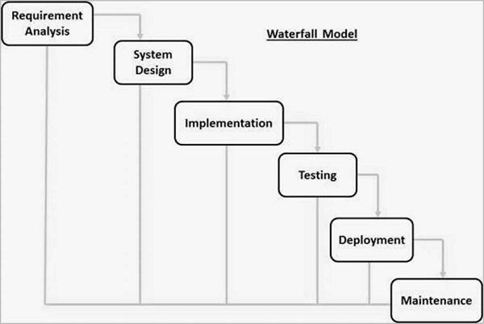

The Development phases in Waterfall model for Active Chat Monitoring and Suspicious Chat Detection over internet are −

* **Requirement Gathering and analysis** :- for our model we required details like:
  + - IP address of both chatting parties
    - Chats of both parties
* **System Design** :- This Model is basically an online chatting site. Two random people can chat online using our interface. The chats are scanned for traces of defaming or any other suspicious chat.

So, following System Specification are needed.

* + - Minimum 16GB ram
    - 1 TB HDD as Server for storing chats
    - Active Internet Connection
    - Any Suitable Browser
* **Implementation** − With inputs from the system design, the system is first developed in small programs called units, which are integrated in the next phase.

So, there are two units are as follows.

* + - **Frontend:** 
      * Here we develop a code for frontend which is the chatting interface displayed on loading of the site.
    - **Backend:**
      * Here we store the cats in the DB server and are simultaneously scanned using our comprehensive AI technology.
      * Sometimes the chats are also monitored by a real person

* **Integration and Testing** :-
  + - Firstly for the friendly check, we assign two of the employees to chat by deliberately using offensive words.
    - For a wider test two random persons are given the opportunity to test the web application.
    - Finally for the public test, users are free to report bugs within the suspicious chat detection.
    - all of the bug fixes are then integrated together for improving our web application.
* **Deployment of system** :-
  + - In this phase once the functional and non-functional testing is done; the product is deployed in the web free for the users.
* **Maintenance** :-
  + - There are some issues which come up in the client environment. To fix those issues, patches are released. Also to enhance the product some better versions are released. Maintenance is done to deliver these changes in the web application.

**Representation of the different phases of the Spiral Model.**

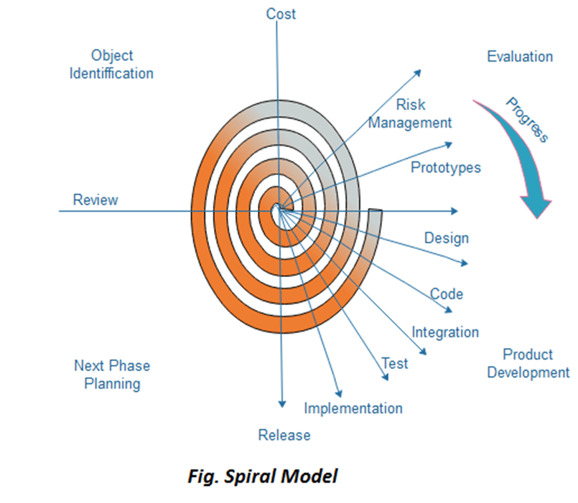

The Development phases in Spiral model for Active Chat Monitoring and Suspicious chat detection over internet are:-

· **Objective setting:** Each cycle in the spiral starts with the identification of purpose for that cycle, the various alternatives that are possible for achieving the targets, and the constraints that exists.

· **Risk Assessment and reduction:** The next phase in the cycle is to calculate these various alternatives based on the goals and constraints. The focus of evaluation in this stage is located on the risk perception for the project.

· **Design:**- This Model is basically an online chatting site. Two random people can chat online using our interface. The chats are scanned for traces of defaming or any other suspicious chat.

So, following System Specification are needed.

* + - Minimum 16GB ram
    - 1 TB HDD as Server for storing chats
    - Active Internet Connection
    - Any Suitable Browser

· **Implementation & Code:**- With inputs from the system design, the system is first developed in small programs called units, which are integrated in the next phase.

So, there are two units are as follows.

* + - **Frontend:** 
      * Here we develop a code for frontend which is the chatting interface displayed on loading of the site.
    - **Backend:**
      * Here we store the cats in the DB server and are simultaneously scanned using our comprehensive AI technology.
      * Sometimes the chats are also monitored by a real person

· **Integration and Testing** :-

* + - Firstly for the friendly check, we assign two of the employees to chat by deliberately using offensive words.
    - For a wider test two random persons are given the opportunity to test the web application.
    - Finally for the public test, users are free to report bugs within the suspicious chat detection.
    - all of the bug fixes are then integrated together for improving our web application.

·

**Release :-**

In this phase once the functional and non-functional testing is done; the product is deployed in the customer environment or released into the market.

**Conclusion:** - Here, we successfully studied and understand the two traditional software development model.

AD